

**ICT DEPARTMENT**

**DIGITAL ONLINE VOTING MANAGEMENT SYSTEM**

**PRESENTED BY:**

**KIRIMI HERMON MWIONGERA: DIT-02-1727/2020**

**SUPERVISOR:**

**MR. TITUS NJIRU**

**MAY 2021.**

A research proposal Submitted in partial fulfillment of the requirements for the award of Diploma in Information Technology of Zetech

University.

# DECLARATION

I declare that this research project is my original work and has not been submitted in any other institution for the award of diploma in information technology by Zetech University

NAME: REG.NO:

KIRIMI HERMON MWONGERA DIT-02-1749/2020

Signature …………………………… Date ……………………………………..

**SUPERVISOR**

I confirm that this research proposal was carried out by the student under my supervision.

TITUS NJIRU

Lecturer,

Department of ICT

Zetech University.

Signature ………………………………. Date…………………………………….

# ACKNOWLEDGMENT

I give my special thanks to God for his sufficient grace, good health and sound mind throughout my study period. My supervisor who helped shed light in different areas that I needed to focus on in my project and therefore contributed to a more comprehensive project. I thank friends who helped in different areas as regards to the anticipated project.

# ABSTRACT

Digital Online Voting Management system provides online voters login forms for candidates where student(voters) registerred and are allowed to log in as voters using their voters ID and default password which, they are allowed to update. Each registered user(voters) has a default password to log in. The system allows the administrator to add qualified candidates and also have the right to delete them from System. The system provides an interactive platform where voters and candidates interacts. The system allows preliminary voting and the results are presented in table format. The system compute and gives the election results for all the posts. The main objective of this system is to design, develop and implement an efficient, user friendly, interactive web based residential voting system. The methodology used is waterfall.

List of figures

List of tables

# LIST OF ABBREVIATIONS

ICT Information communication Technology

IT Information Technology

ERD Entity Relationship Diagram

DFD Data Flow Diagram

PHP  PHP Hypertext Preprocessor

HTML Hypertext Mark Link

DOVS Digital Online Voting System

FR Functional Requirement

TC Test Case

WAN Wide Area Network

Table 1

## CHAPTER 1: INTRODUCTION

## 1.0 Introduction

The DOVMS system will provide online voter registration form for voters, candidates and delegates where registered voters will be allowed to log in as either voters, delegates or candidates. Each registered user will have a password to log in. The system will provide an interactive platform where voters, candidates and delegates will interact and thus candidates will perform their campaigns in the charting platforms. The system will allow preliminary voting and the results will be represented graphically and in percentages. The system will compute the election results for all the posts and provide reports for the whole election process (counting system). The objective activity for this system is to develop a system that is trusted efficient and reliable to the users.

## 1.1 Problem statement

The present voting system applicable in online residential voting has proved inefficient due to the voters’ and candidate registration and vetting processes being slow, the manual collection of results takes time and gives room for result manipulation, also the inaccessible nature of election venues which at times may not be appropriate., the destruction of election equipment and violence conducted on personnel undertaking the voting process and other voters can be curbed through digital voting system.

## 1.2 Objectives

* To develop voters’ management system, that allow voters to vote for their respective candidates and view the ongoing voting status and updates.
* To develop a candidate management system, that allows the candidate to be registered.
* To develop administration management system, that allow admin to manage all voting process, to reject a candidate’s application, nullify candidate’s results/election, announce and post final voting results.
* To develop counting management system, that compute candidate’s votes and present results in a graphical interface (Bar chart).

# CHAPTER 2: LITERATURE REVIEW

## 2.1 Introduction

Through the growth of ICT, applications have been developed to improve Technology has promoted diverse areas in ICT and other related areas.  The Digital online voting system is a web-based system that is related with web-based technologies such as client-server and database properties that determine the software requirements of this project..

## 2.2 Theoretical review

Different developers have been able to implement systems for use of digital online voting systems in schools and other institutions.

## 2.2.1 International

France has implemented Internet voting in national elections since 2007 and the percentage of voters voting via Internet has trended up in each successive election

France In January 2007 France's [UMP](https://en.wikipedia.org/wiki/Union_for_a_Popular_Movement) party held a national presidential primary using both remote electronic voting and with 750 polling stations using touch screen electronic voting over the Internet. The election resulted in over 230,000 votes representing a near 70% turnout.[[54]](https://en.wikipedia.org/wiki/Electronic_voting_by_country#cite_note-Ref_j-54)

[Elections in France](https://en.wikipedia.org/wiki/Elections_in_France) utilized remote Internet voting for the first time in 2003 when French citizens living in the United States elected their representatives to the [Assembly of French Citizens Abroad](https://en.wikipedia.org/wiki/Assembly_of_French_Citizens_Abroad). Over 60% of voters chose to vote using the Internet rather than paper. The [Forum des droits sur l'Internet](https://web.archive.org/web/20071108222754/http:/www.foruminternet.org/) (Internet rights forum), published a recommendation on the future of electronic voting in France, stating that French citizens abroad should be able to use Internet voting for Assembly of the French Citizens Abroad elections.[[55]](https://en.wikipedia.org/wiki/Electronic_voting_by_country#cite_note-Ref_k-55) This recommendation became reality in 2009, with 6000 French citizens choosing to make use of the system.[[56]](https://en.wikipedia.org/wiki/Electronic_voting_by_country#cite_note-Ref_l-56)

On March 6, 2017 France announced that Internet voting (which had previously been offered to citizens abroad) would not be permitted in the 2017 legislative elections due to cybersecurity concerns.

## 2.3 Empirical Review

### (Implementation)

The DOVS system provide online voter login form for resident voters, where registered voters will be allowed to log in as voters. Each registered user has a default password and auto generated voters ID to log in, which voters are allowed to updated

The system allows the voters to access information about their desired leader whenever they choose to,and chose their leader according to their own judgement. It will also count and compute the total votes of each candidate and display the candidates with the most votes in graphical interface(Bar charts). The results will be represented graphically. The system will compute the election results for all the posts and provide reports for the whole election process

.

# CHAPTER 3: METHODOLOGY

# Development Methodology

The development methodology used is the waterfall. This included the analysis, design, implementation and the testing steps.

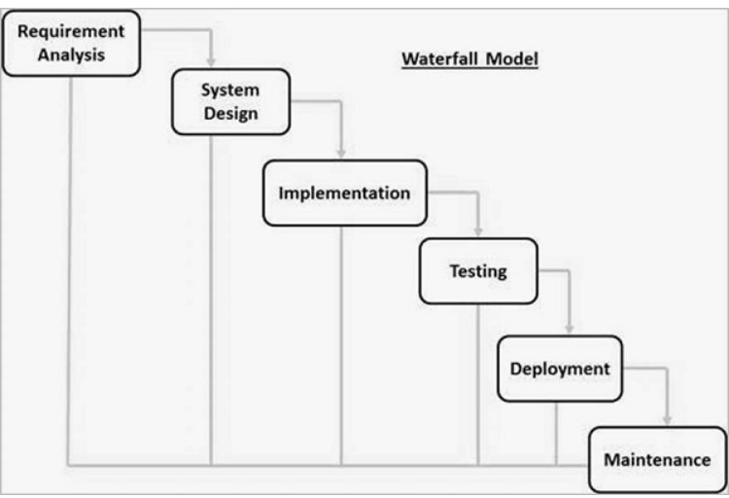

## *3.1.1Analysis*

The researcher analyzed the requirements, and fully understood the problems. Analysis was conducted on the current systems failures to establish the problem definitions and how to curb them. Analysis was also conducted to find the stengths of the system and help better improve its functionality.

* + - 1. Logical Design

Logical design characteristically was looked at the intended system from a logical perspective without considering physical requirement. The project needed a logical design that will model the flow of data and information through the system from input to output. Logical design also modelled the security checks that the system will be using as well as the formats for all data items in the system.

* + - 1. Physical Design

The physical design was majorly connected with how the physical architecture of the entire system interact to each other to achieve its objectives. It modelled the user interfaces, the server architecture and the database models.

## *Implementation*

Once the designs were functioning properly,technical implementation began. Being that the project serves only the web platforms, coding took place in two phases.

3.1.2.1 Database Coding Phase

Candidates Details

Upload

LOG IN

Sign Up

Delegates/Voters Details

Voters/Delegates

Candidate

Select

Votes Manager

Vote

Results

Count Store

Statistical Data

System

Create

The backend rely on implementation of MySQL database. The database is relational in architecture and host tables, which are abstracted into views for the front end and by access level specifications. All the system’s data are stored and processed here in this phase.

3.1.2.2 Web Coding

The project coded in HTML + JavaScript +CSS+PHP for the web platform.

## 3.1.3 Testing

From implementation testing is done before the system is provided to the public, The system was tested in design documents, personas and user case scenarios to run comprehensive tests including the Components testing and on the finished applications

# 

# CHAPTER 4. SYSTEM ANALYSIS AND DESIGN

# System requirements

**4.1.2 Technical Requirement**

The following are the requirements of the system. The system only run on the web platforms and the expected performance of the system depends on the system requirements.

*Table 4.1.2.1 Illustrates Technical Requirements*

|  |  |  |
| --- | --- | --- |
| **CATEGORY** | **REQUIRED** | **DESCRIPTION** |
| **OS** | Apple iOS, Android, MS Windows, Mac | Web browser host Platform OS |
| **Web Browser** | Above Chrome 12, Firefox 14 | For Displaying Webpages |
| **JavaScript** | Supported and Enabled | Front end Logic execution |
| **Processing** | Single/Multi Core + 1GHz and Above | Microprocessor |
| **RAM** | 512MB and Above | Host Operating System Memory |
| **Internet Access** | 1MBps Downlink, 512KBps Uplink | WAN Online Functionality |

### 

### 4.1.3 Functional requirements

1. The system should allow a voter to login and vote for his/her favorite candidates
2. The system should allow the administrator to have rights to reset election, set election, add candidates
3. The system should allow only one candidates to be voted for at a times and once voting is complete the voter is locked out of the voting process
4. The system should allow voters to see the results after voting

### 4.1.4 Non-functional requirements

1. The analysis and presentation of results should be at an appropriate time
2. The systems should be reliable.
3. The system should be efficient

**CHAPTER 5. SYSTEM DOCUMENTATION AND DESIGN**

**5.1 Database design**

*Tables 5.1.1 System designs figures*

## Figure 4 Candidates Table(MySQL)

## 

*Figure 5 history Table (MySQL*)

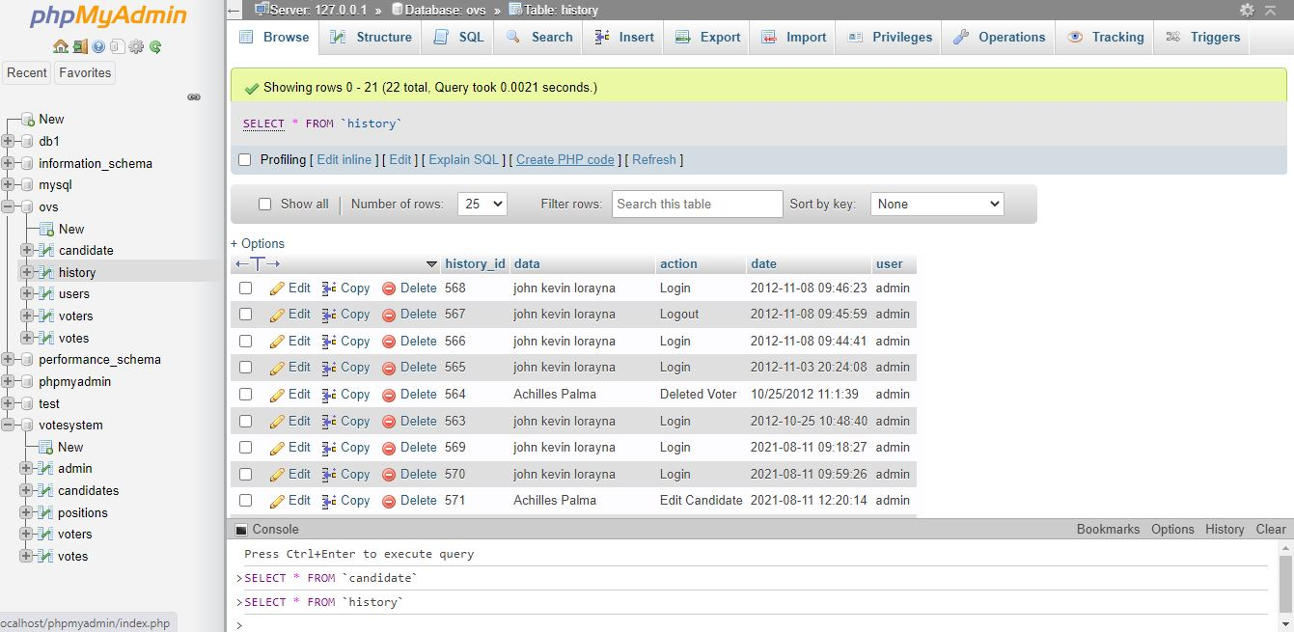

*Figure 6 users Table (MySQL)*

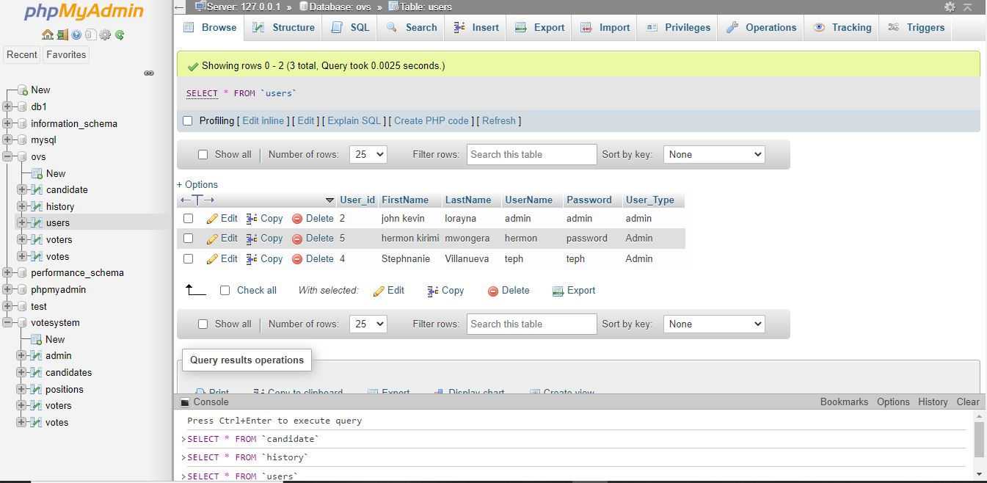

*Figure 7 voters Table (MySQL*

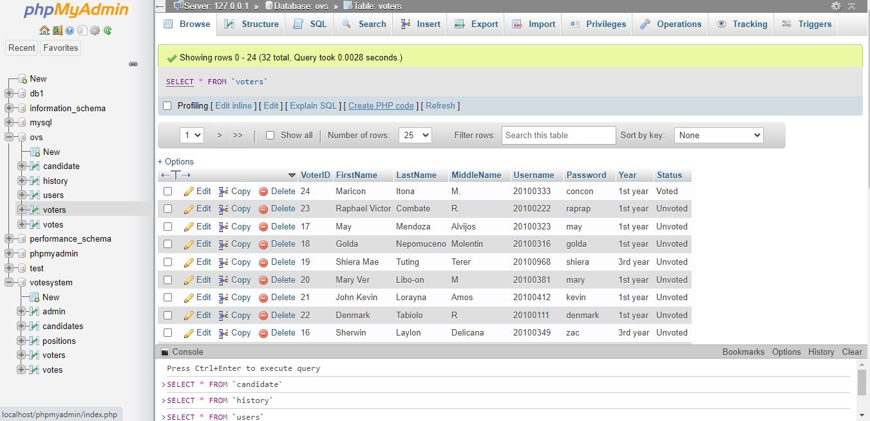

*Figure 8 vote Table (MySQL)*

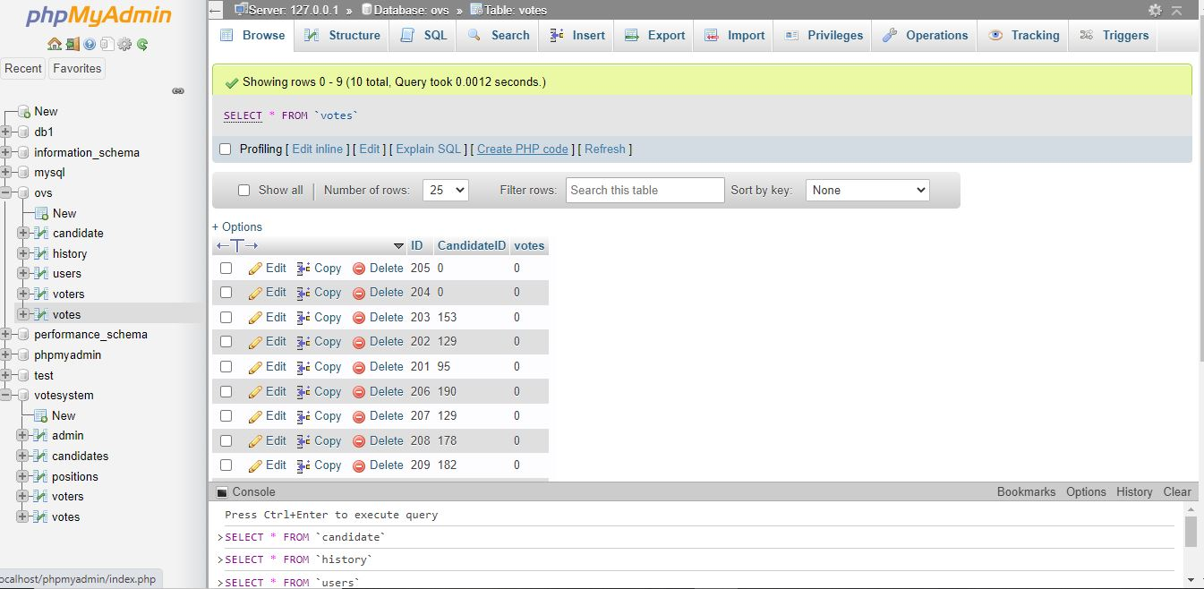

**INPUT DESIGN**

*Figure 9 users Log in form*

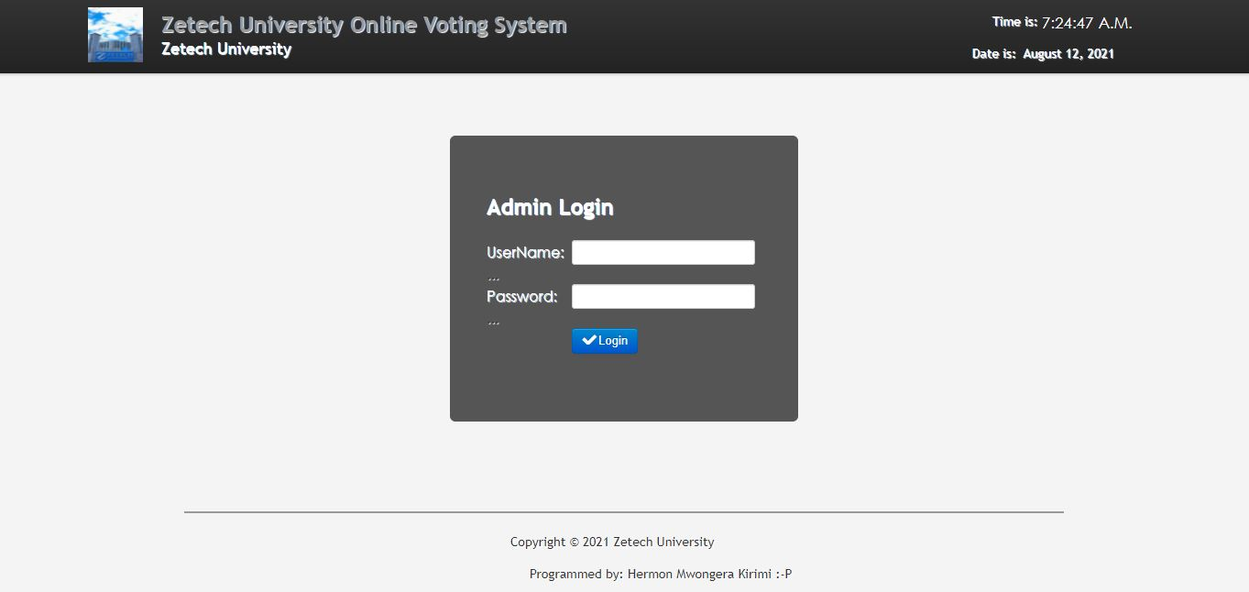

*Figure10 Admins Home page*



*Figure11 voters login*

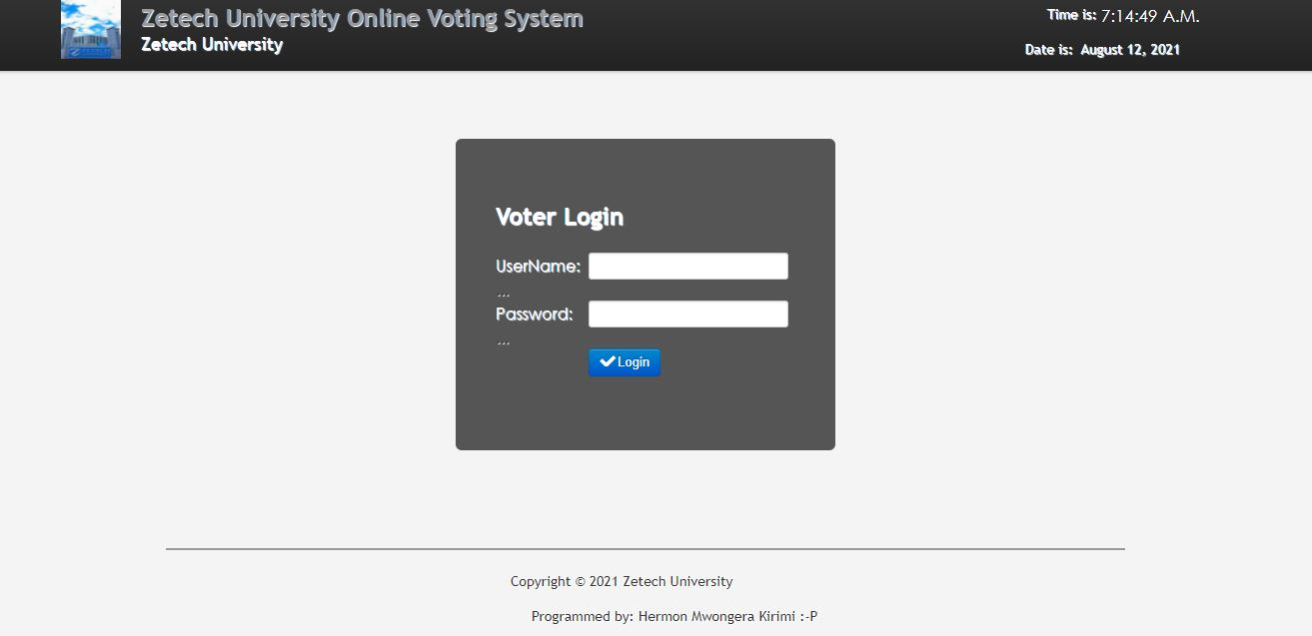

*Figure11 voters Home page before voting*

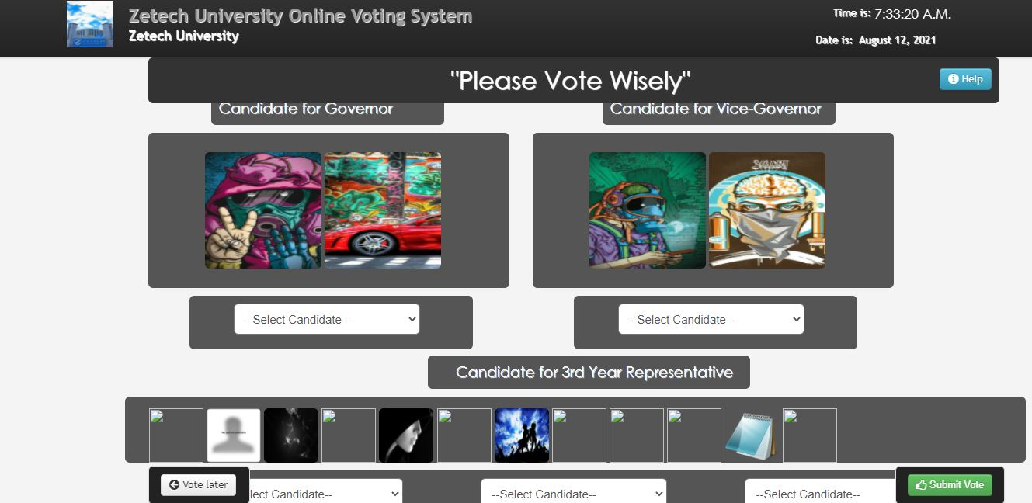

*Figure12 voters Home page after voting*

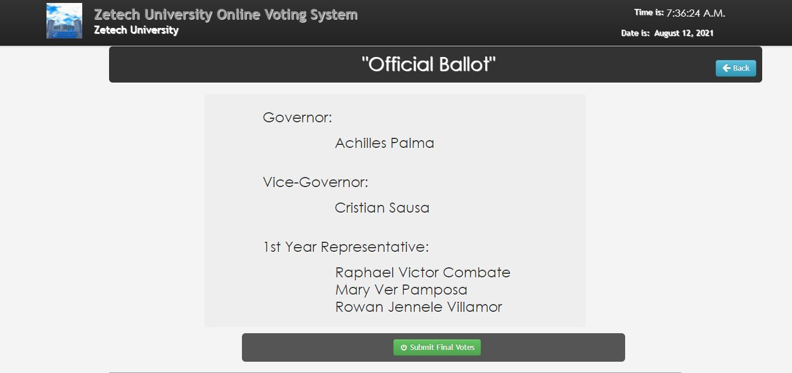

*Figure12 preliminary voting report*

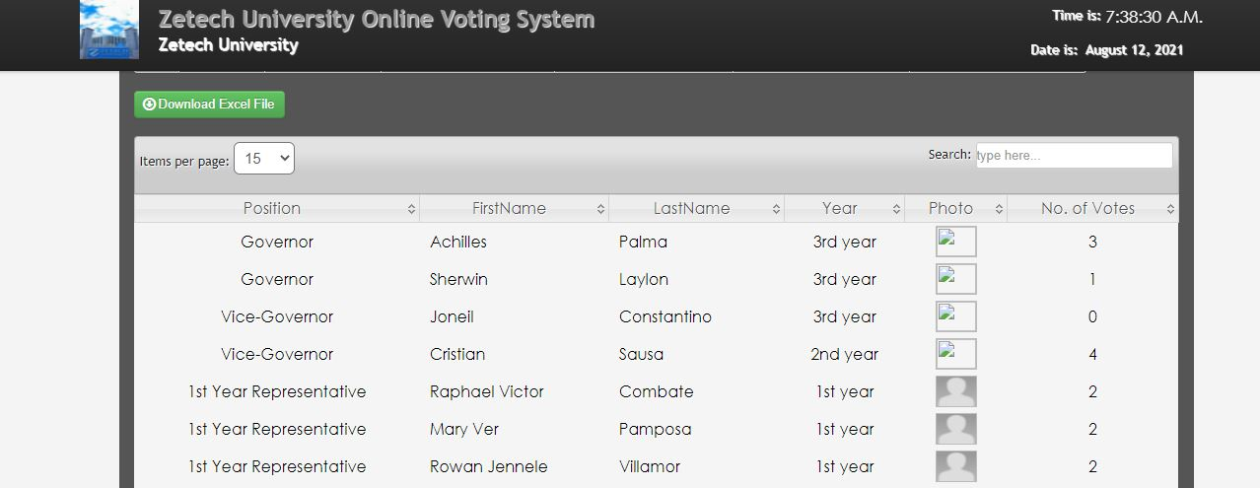

# CHAPTER 6. IMPLEMENTATION

## 6.1 Introduction

The system was be implemented using SQL for creating database and relation structures, PHP for creating codes that link the forms to the database, HTML, JavaScript and CSS for designing and styling the interfaces.

### 6.1.1 SQL

It is a structured query language that was used in creating database and relation structures. SQL was selected because of the following advantages. It is user friendly and easy to use.

### 6.1.2 PHP

PHP is a scripting language that I used in linking the HTML codes to the database.I used PHP because it is available on Microsoft windows and can run on any other platform with ease.

### 6.1.3 HTML and CSS

HTML was selected to be used as the web template to design interfaces because of the following advantages:

1. It has a build in functions hence easy to use.
2. HTML is available for Microsoft Windows.

**CHAPTER 7. SYSTEM TESTING**

**7.1 Unit testing**

Unit testing, The software with a small piece of source code (unit, component, and/or function) of the same software. During performing tests, some hypotheses were made, and the testing was then determined if true or false. This way, the developer was able to check whether a unit behaves in the required manner. the sources used in unit testing were created by the developer as a part of software development. The following unit tests were performed on the system

.

*Table 7.1.1 Test Cases for Unit Testing*

|  |  |  |  |  |  |
| --- | --- | --- | --- | --- | --- |
| TEST CASES (TC#) | TEST NAME | TEST DESCRIPTION | S/W | | TEST ENVIRONMENT |
| TC1 | Navigation Tests | This test verifies if the user is able to navigate the site and access all URLs. Testing a login  scenario | zovs-core | | Windows 10 Pro, 1TB HDD, 8GB RAM, Xamp(Apache) Server, MySQL Server |
| TC2 | Authentication Tests | This test verifies the username and  password to access zovs core | zovs- core | Windows 10 Pro, 1TB HDD, 8GB RAM, Xamp(Apache) Server, MySQL Server | |

# 7.2 Interface testing

Interface Testing is used to evaluate whether systems or components pass and control data correctly to one another and for the purpose of verifying if all the interactions between these modules are working properly with minimal errors. The developer created a checklist that outlined all the functional requirements of the system and the various test case .

|  |  |
| --- | --- |
| **Functional requirement (FR#)** | **Description** |
| **FR1** | Login and Authentication for users of the application |
| **FR2** | Updating profiles in the system |
| **FR3** | Set of Election by Admin |
| **FR4** | Voting and results |

*Table 7.2.1 Functional requirements descriptions*

# 7.3 Test cases

The tables below shows how each of the functional requirements were assessed using Test Cases.

*Table7.3 1 Test Case One Details and Results*

|  |  |  |  |  |  |  |  |
| --- | --- | --- | --- | --- | --- | --- | --- |
| **TEST CASE (TC#)** | **FUNCTIONAL REQUIREMEN T(FR#)** | | **TEST NAME** | **TEST DESCRIPTION** | | **S/W** | **TEST ENVIRONMET** |
| **TC1** | FR1 | | Authenti | Verify and authenticate | | zovs- | Windows 10 Pro, |
|  |  | | cation | user using Auto generated Voter ID | | core | 1TB HDD, 8GB |
|  |  | |  | and password | |  | RAM Xamp |
|  |  | |  |  | |  | (Apache) Server, |
|  |  | |  |  | |  | MySQL Server |
|  |  | |  |  | |  | Android 6.0 |
|  |  | |  |  | |  | Marshmallow, 3GB |
|  |  | |  |  | |  | RAM |
| **Action Performed**  Auto generated Voter ID and password | | **Action’s output**  Navigate to user’s home page | | | **Valid Input**  Well formatted Voter ID and password | | |

|  |  |  |  |  |  |
| --- | --- | --- | --- | --- | --- |
| **TEST CASE (TC#)** | **FUNCTIO NAL REQUIRE MENT** | **TEST NAME** | **TEST DESCRIPTIO N** | **SOFTW ARE** | **TEST ENVIRONMENT** |
| **TC2** | FR2 | Updating | Update Profiles  For voters and candidates | zovs-core | Android 6.0  Marshmallow, 3GB RAM |
| **Action Performed Action’s output Valid Input Invalid Input Edited Candidate’s** All candidate’s Navigate to None  details candidates including name,  skills, post about, photo, page  edited details and display | | | | | |

*Table 7.3.2 Test Case Two Details and Results*

*Table 7.3.3 Test Case Three Details and Results*

|  |  |  |  |  |  |
| --- | --- | --- | --- | --- | --- |
| **TEST CASE (TC#)** | **FUNCTIO NAL**  **REQUIRE MENT** | **TEST NAME** | **TEST DESCRIPTIO N** | **SOFTW ARE** | **TEST ENVIRONMENT** |
| **TC3** | FR3 | Set of Election | Admin Set election to be voted for if not it remains inactive | zovs- core | Windows 10 Pro, 1TB HDD, 8GB RAM,  Xamp(Apache) Server, MySQL Server |
| **Action Performed Action’s output Valid Invalid Input**  **Input**  **Admins Set the** Election Name none none  **Election name** | | | | | |

|  |  |  |  |  |  |
| --- | --- | --- | --- | --- | --- |
| **TEST CASE (TC#)** | **FUNCTIO NAL**  **REQUIRE MENT** | **TEST NAME** | **TEST DESCRIPTIO N** | **SOFTW ARE** | **TEST ENVIRONMENT** |
| **TC4** | FR4 | Voting | Voting of Candidates | zovs-core | Windows 10 Pro, 1TB HDD, 8GB RAM,  Xamp(Apache) Server, MySQL Server |
| **Action Performed Action’s output Valid Input Invalid Input**  **Voted the various** Pop up alert Illegible bogus text  **candidates** displaying success in voting/liking | | | | | |

*Table 7.3.4 Test Case Four Details and Results*

# 7.4 Usability testing

The table below summarized tests that were performed to ascertain the usability and experience of users while interacting with the system.

*Table 7.4.1 Usability Testing Results*

|  |  |
| --- | --- |
| **Element** | **Output** |
| **Flow from start to finish** | Yes |
| **Feedback from Actions performed** | Instant Feedback |
| **Seamless Navigation** | Yes |
| **Performance** | Optimal |
| **Runtime error messages** | None |
| **Slow or delayed loading** | Acceptable |

# 7.5 Integration testing

 Integration testing was conducted to evaluate the compliance of the system or component with specified functional requirements. All the screens, functions, stores, data tables and other modules were connected with seamless interfacing. All the required outputs were running successfully as expected from the systems and all inputs were validated and specified as per the developers requirements.

# CHAPTER 8. LIMITATION

Lack of enough web development skills in programming Languages used and inadequate time.

# CHAPTER9. CONCLUSION

The system allows users to Login the system. The system allows Admin to have rights to terminate election by resetting, setting election dates and add qualified candidates. The system also enables voters to do the voting online and the results are displayed for all users to view. The system allows users to view the candidate’s profiles information. The system then compute results for the whole election process.

# CHAPTER 8. RECOMMENDATIONS

The current voting system has proved that it is reliable and efficient in carrying out its specifications. The system promoted equality and fairness but still has some limitations to the amount of information that can be accessed by outside parties. it would be useful to review the voters id’s to a further more complex id or a biometric system to promote security and providing access to residents Online in case of implementing candidates and voters details .allowing furthermore development of the system will increase efficiency of the system.

**REFERENCES**

* + 1. Al-Ameen, A.; Talab, S.A., "E-voting systems vulnerabilities," Information Science and Digital Content Technology (ICIDT), 2012 8th International Conference on , vol.1, no., pp.67,73, 26-28 June 2012 URL: [http://ieeexplore.ieee.org/stamp/stamp.jsp?tp=&arnumber=6269229&isnumber](http://ieeexplore.ieee.org/stamp/stamp.jsp?tp&arnumber=6269229&isnumber) =6269212
    2. Cui Zhen; Dai Xiang, "A practical distributed electronic voting system," Electric Information and Control Engineering (ICEICE), 2011 International Conference on , vol., no., pp.1095,1099, 15-17 April 2011doi:10.1109/ICEICE.2011.5777548URL:[http://ieeexplore.ieee.org/stamp/stamp.jsp?tp=&arnumber=5777548&isnumber](http://ieeexplore.ieee.org/stamp/stamp.jsp?tp&arnumber=5777548&isnumber) =5776798
    3. Gritzalis, D. (2002). Secure Electronic voting. Seventh Computer Security Incident Response Team Workshop Syros, Greece.
    4. Melanie Volkamer (2010), ―Electronic Voting in Germany‖, Data Protection in a Profiled World, DOI 10.1007/978-90-481-8865-9_10, © Springer Science+Business Media B.V. 2010
    5. TahaKh. Ahmed and Mohamed Aborizka (2011), ―Secure Biometric E-Voting Scheme‖, ICICIS 2011, Part I, CCIS 134, pp. 380–388, 2011. © Springer-Verlag Berlin Heidelberg 2011
    6. Google Wikipedia electoral voting by country – Estonia, France.

# Appendices